Sprint 2 – Accuracy Design Document

November 17, 2021

Table of Contents

1. Executive Summary 3

1.1 Project Overview 3

1.2 Purpose and Scope of this Specification 3

2. Product/Service Description 3

2.1 Product Context 3

2.2 User Characteristics 3

2.3 Assumptions 3

2.4 Constraints 3

2.5 Dependencies 4

3. Requirements 4

3.1 Functional Requirements 5

3.2 Security 5

3.2.1 Protection 5

3.2.2 Authorization and Authentication 6

3.3 Portability 6

4. Requirements Confirmation/Stakeholder sign-off 6

5. System Design 6

5.1 Algorithm 6

5.2 System Flow 6

5.3 Software 6

5.4 Hardware 6

5.5 Test Plan 7

5.6 Task List/Gantt Chart 7

5.7 Staffing Plan 7

# Executive Summary

## Project Overview

This product is one leg of a larger product testing the abilities of the Sphero SPRK+ robot using different courses / sprints. Each course is located on the floor of room HH-208. This part of the project is called the Accuracy sprint. The goal is for the robot to navigate the path in the shape of a figure 8 indicated by the blue lines. A video will be taken of the robot completing the sprint. It will then be turned in to the professor alongside the block code and other requested information.

## Purpose and Scope of this Specification

**In scope**

This part of the project involves testing for Accuracy only, as explained in section 2.1.

**Out of Scope**

This part of the project does not involve testing for Endurance (already completed) or Agility.

# Product/Service Description

## Product Context

This product is part of a larger project containing three different sprints- Endurance, Accuracy, and Agility. This is the second of the three products- the Accuracy sprint. All three of these products will be presented through video inside of a larger presentation, alongside other relevant information.

## User Characteristics

* Our group of three students will be using the product during testing and while taking the final video of the sprint. We have some experience using the robot, as this is the second of three sprints, though we have minimal experience having the robot complete more complex tasks such as the figure 8. Some of us have experience with software development in general and at least one of us has used JavaScript-based block code before.

The professor will also be testing our code.

## Assumptions

We are to use an SPRK+ robot and the Sphero Edu application for development. We must use the predetermined course located inside room HH-208. The application can be used on mobile or a laptop, meaning that the robot can be run from either device. We are using phones to film the robot (the program can also be run on the phone while filming).

## Constraints

The room containing the course for the Accuracy sprint is not always available, therefore limiting the times at which the group can meet and test the robot. When the room was available, multiple groups of people were often there testing their own robots at similar times. Our group already had some time constraints and could only meet up at certain times, so this was an issue because we could not fully take advantage of that time.

## Dependencies

* Any dependencies are explained inside the requirements chart in section 3.1.

# Requirements

## Functional Requirements

| Req# | Requirement | Comments | Priority | Date Rvwd | SME Reviewed / Approved |
| --- | --- | --- | --- | --- | --- |
| ACCUR_01 | Robot must successfully run figure eight course 5 times | Points deducted if robot does not go around 5 times  Robot should go around first circle and continue to second and repeat this 4 more times, following arrows | 1 | 11/11 | 11/11 |
| ACCUR_02 | Robot must stay within path provided | Points deducted if robot strays from path  We accepted tests as long as the robot did not stray completely from the path and stayed about on track- not necessarily directly on blue line (which indicates the track on the floor) | 1 | 11/11 | 11/11 |
| ACCUR_03 | Robot must start and finish in square provided | Points deducted if robot does not finish in same place it started  Square is located in the middle of the two circles | 1 | 11/11 | 11/11 |
| ACCUR_04 | Robot will speak ‘I am the winner’ upon finishing | This comes first in the block code, but happens at the same time as ACCUR_05 | 1 | 11/11 | 11/11 |
| ACCUR_05 | Robot will flash multicolored lights for 5 seconds upon finishing | Happens at the same time as ACCUR_04 | 1 | 11/11 | 11/11 |

## Security

### Protection

We did not feel that it was worth putting more extreme protective measures on our program. We did use a password protected account on the Sphero Edu application, however, that would protect our code. The robot itself is also secured inside of a case when not being used.

### Authorization and Authentication

N/A

## Portability

This system is overall not portable. The track is located in HH-208, and therefore the robot must be run in this room in order to follow the requirements (as seen in section 3.1). The robot itself and the device being used to run the robot can be moved around, but as the device must use Bluetooth to connect to and control the robot, the robot must be near the device in order to run.

# Requirements Confirmation/Stakeholder sign-off

|  |  |  |
| --- | --- | --- |
| Meeting Date | Attendees | Comments |
| 11/11 | All | All requirements confirmed |

# System Design

## Algorithm

* Start on square in center of figure 8
* Follow forward path around first circle with spin of -360°
* Follow forward path around second circle with spin of 360°
* If amount of completed laps is <5, repeat previous two steps
* Stop on square in center of figure 8 after 5 laps completed
* Speak “I am the winner”
* Flash multicolored lights for 5 seconds

## System Flow

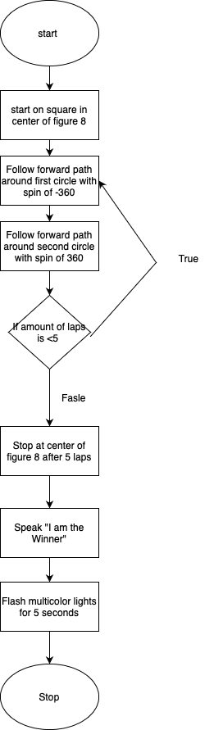

## Software

This product was initially programmed using the Sphero Edu application for Windows. The code was run during testing and edited accordingly using the Sphero Edu application for iPhone (iOS). This application uses block code.

PLEASE NOTE (from Anjali): For the video, I kept accidentally ending the program early forgetting that the lights were still flashing. Unfortunately, our videos were very hit or miss (without changing the code- lot of room for error), and the best one we could get had the lights stop early, even though they were in the code. We had to accept a video with this issue due to time constraints.

The robot does flash for about 5 seconds total in the code due to short pauses between each block (even though all the times depicted don’t add up to 5).

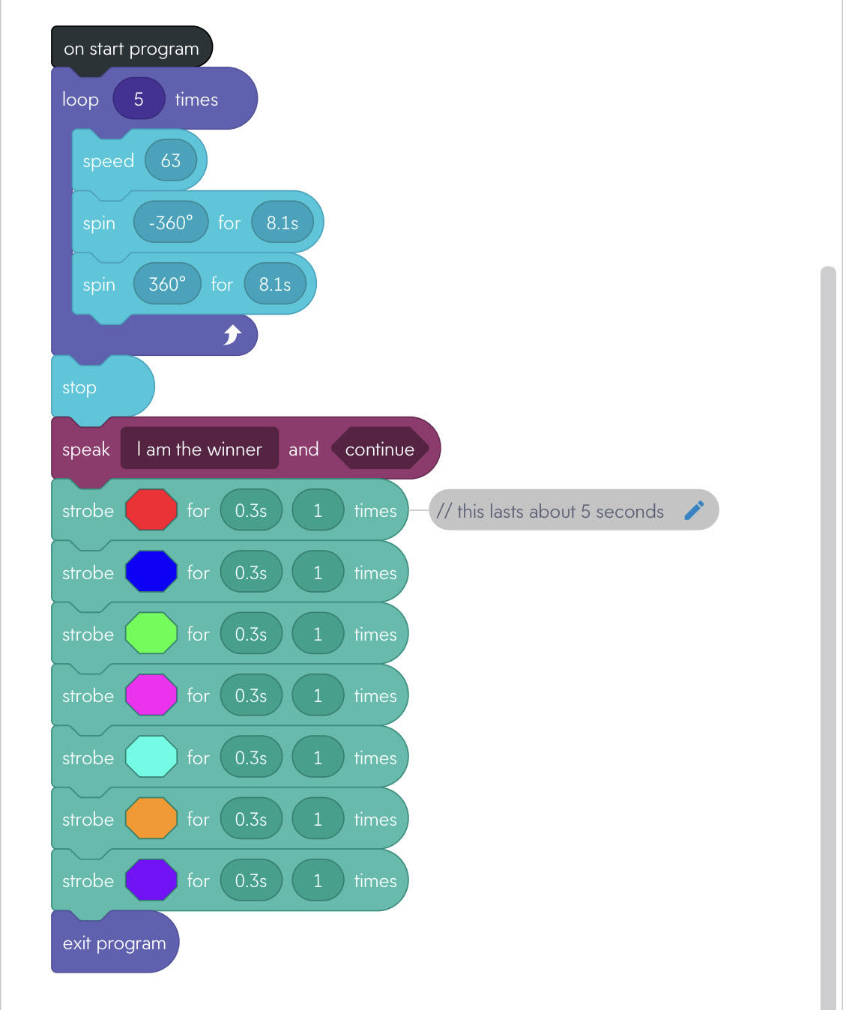

Block code for Accuracy sprint – Sphero Edu app for iOS

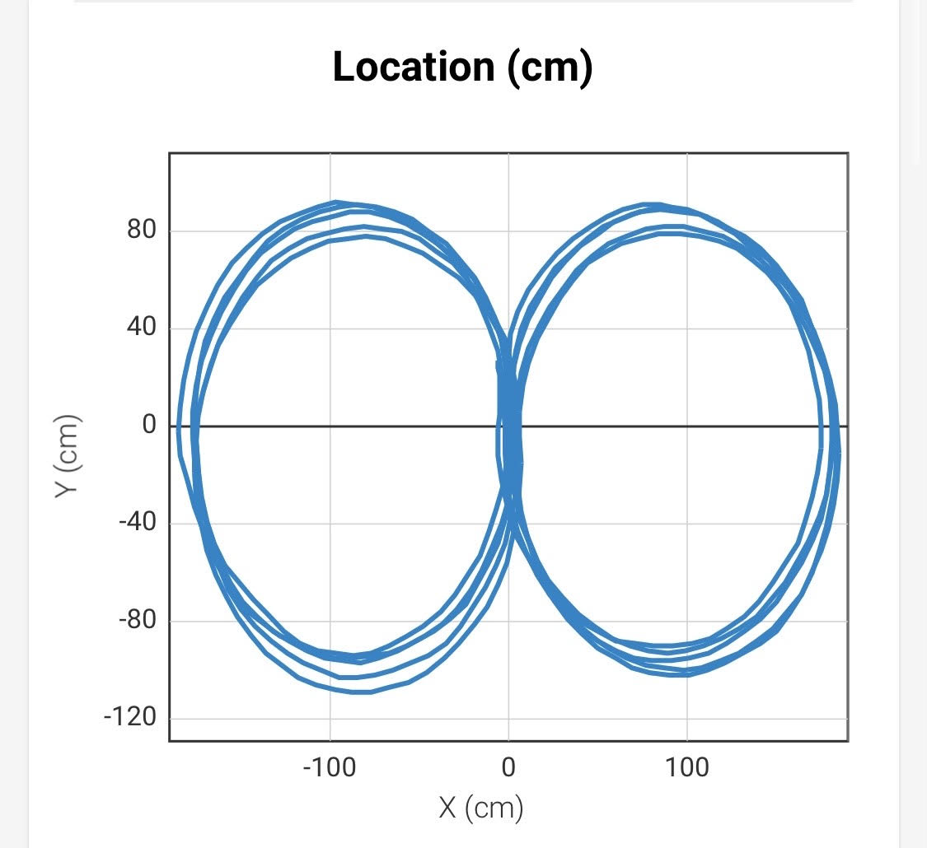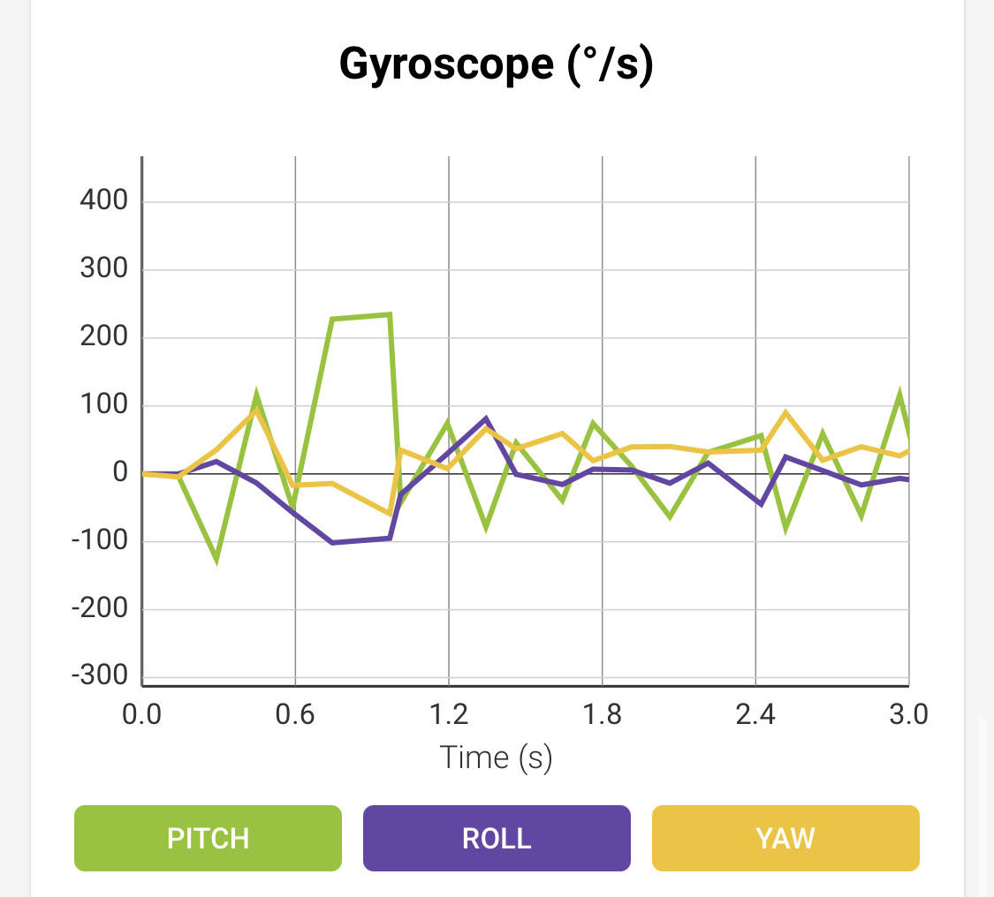

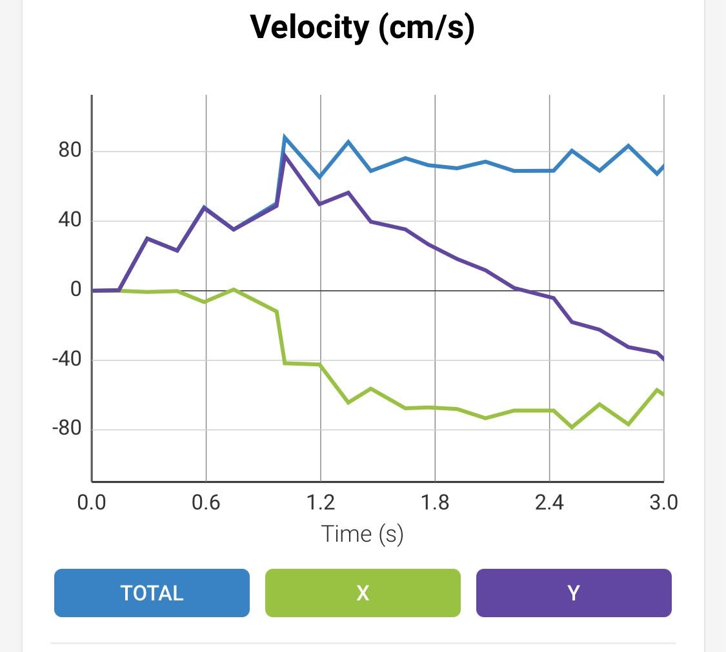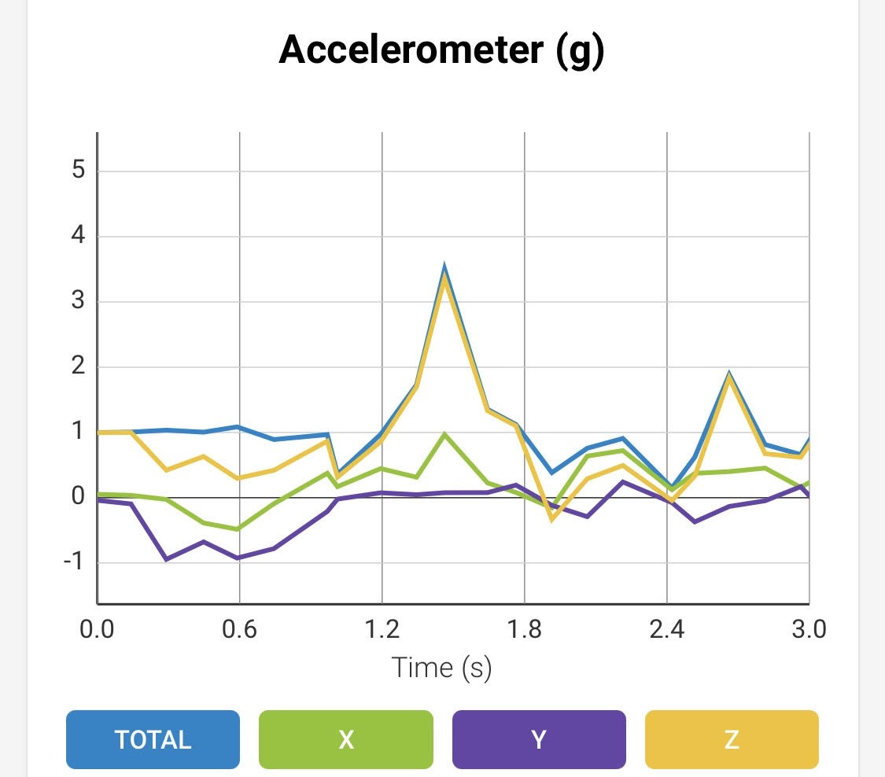

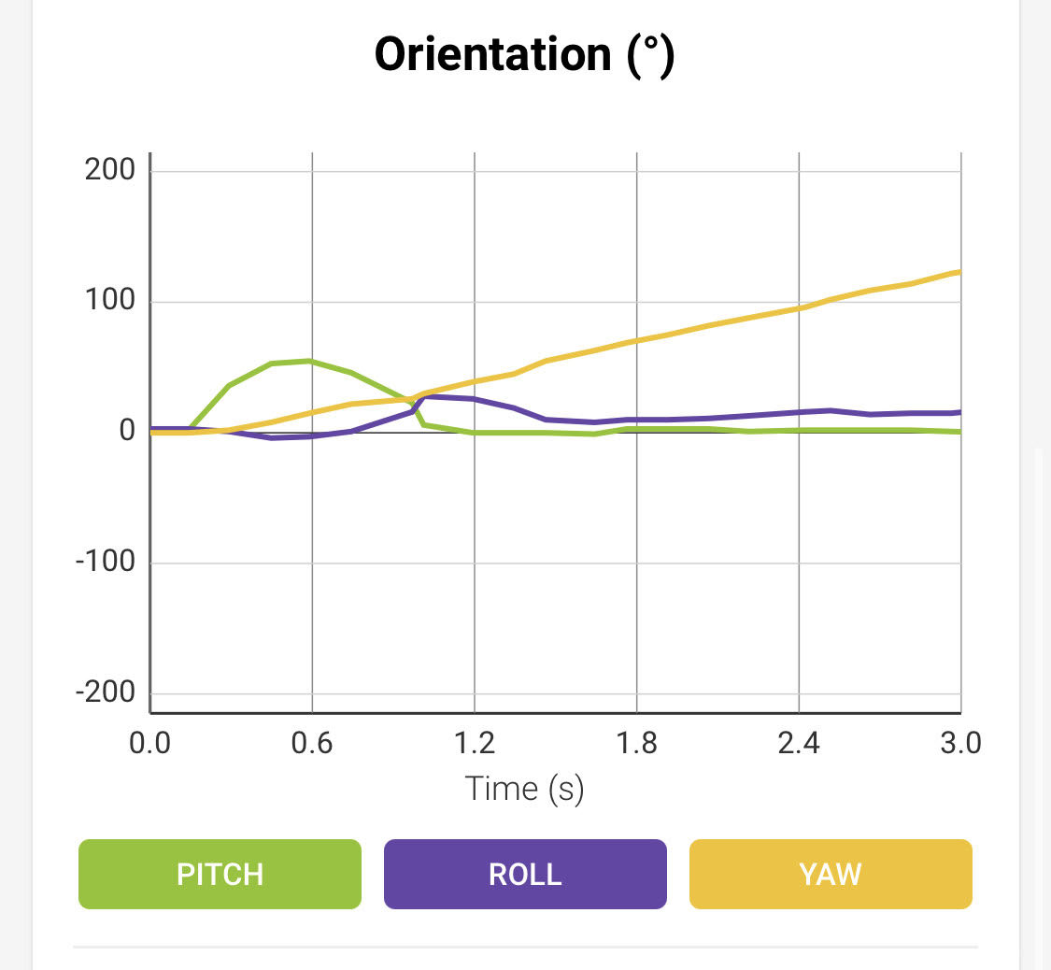 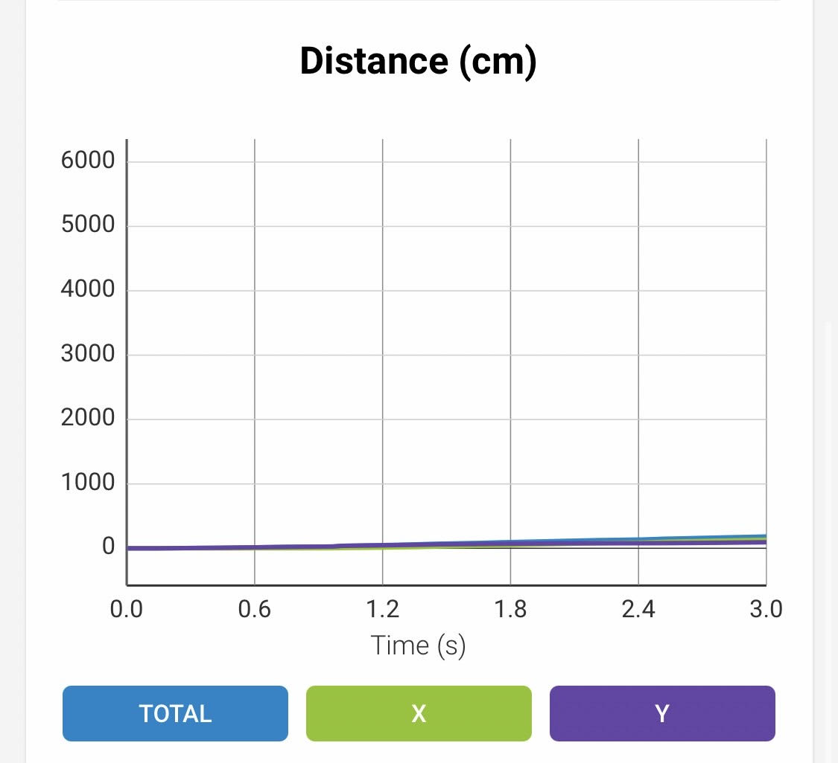

Sensor data diagrams – Sphero Edu app for iOS

## Hardware

The robot being used is the Sphero SPRK+. The block code was programmed using an HP laptop and subsequently edited using an iPhone. The robot was run and filmed using the iPhone as well.

## Test Plan

| **Reason for Test Case** | **Test Date** | **Expected Output** | **Observed Output** | **Staff Name** | **Pass/Fail** |
| --- | --- | --- | --- | --- | --- |
| Robot moves in a circle | 11/11 | Expected failure. Was testing to see if robot would go in a circle using spin command. | Robot spun in place but did not move in a circle. | Anjali | Fail |
| Robot moves in a circle | 11/11 | Expected success. Figured out that robot would need speed block before spin block. | Robot spun in a circle and did not stop. | Anjali | Pass |
| Robot moves in a circle and stops | 11/11 | Robot will move in a circle the same way as previous test case, but will stop after one circle completed. | Robot completed one circle and stopped. | Anjali | Pass |
| Robot travels on first circle of figure 8, starts and stops in center | 11/11 | Expected that robot would fail, as we were using trial and error to figure out size of circle. | Robot’s circle was too small. We would need to increase the duration of the spin. | All | Fail |
| Robot travels on first circle of figure 8, starts and stops in center | 11/11 | Robot will move at least close to the circle and complete the entire circle. | Robot kept drifting off to the side when hitting certain parts of the floor. | All | Fail |
| Robot travels on first circle of figure 8, starts and stops in center | 11/11 | Robot will move at least close to the circle and complete the entire circle. | Robot seemed to complete correctly-sized circle, but continued to drift and also seemed to be completing circle slightly to the right of track. | All | Fail |
| Robot travels on first circle of figure 8, starts and stops in center | 11/12 | Expected that there would be something to fix due to outcome of previous tests. | Was able to correctly orient robot, but circle was too large and it continued to sometimes drift even after fixing tape. | Anjali | Fail |
| Robot completes a smaller circle than previous circle | 11/12 | Robot will complete a smaller circle than the previous, even if it does not stay on track, as spin duration is reduced. | Robot completed a correctly-sized circle- appeared to be the size of the track. | Anjali | Pass |
| Robot travels on first circle of figure 8, starts and stops in center | 11/12 | Robot will stay about on the track. We added case to robot and lowered speed and adjusted duration accordingly to hopefully improve accuracy of the robot. | Robot stayed just about on the track for the first circle. It stopped decently close to the center. | Anjali, James | Pass |
| Robot traverses both circles of figure 8, starts and stops in center | 11/16 | Robot should stay close to the blue line on the entire track, as two circles making up the figure 8 are of at least very similar size | Robot stayed about on the track, but was off track enough to stop a bit far from the center | Anjali, James | Fail |
| Robot flashes multicolored lights for 5 seconds | 11/16 | We isolated this part of the code to ensure that the robot would flash multicolored lights for about 5 seconds. Expected that it would do so. | Robot technically flashed colors for more than 5 seconds, as the block code we used had long pauses between each flash. | Anjali, James | Fail |
| Robot flashes multicolored lights for 5 seconds and speaks “I am the winner” at the same time | 11/16 | Duration of each of the 5 flashes was lowered from 1 second long in order to compensate for pauses. Therefore, total amount of time robot spent flashing lights is expected to be about 5 seconds. Expected that robot would speak while flashing colors. | Robot flashed colors for about 5 seconds total, including pauses, and spoke at the same time. | Anjali, James | Pass |
| Robot traverses both circles of figure 8 5 times, starts and stops in center, flashes multicolored lights for 5 seconds, speaks “I am the winner” | 11/16 | Robot should stay close to the blue line on the entire track. Was not necessarily expected that it would stop in the center. We removed some slightly excessive pauses in the code to hopefully help robot stay on track better | The robot stayed close to the track and stopped just about in the center. However, it consistently strayed the same distance from the circle farthest from the door, indicating that there was some possible fix in either the code or the initial orientation of the robot | Anjali, James | Accepted as Pass, but we would continue trying |
| Robot traverses both circles of figure 8 5 times, starts and stops in center, flashes multicolored lights for 5 seconds, speaks “I am the winner” | 11/17 | Robot should stay close to the blue line on the entire track and stop at least close to the center. | The robot did stay close to the track, but eventually strayed from it on the fourth lap and ended somewhat far from the middle. | Anjali, James | Fail |
| Robot traverses both circles of figure 8 5 times, starts and stops in center, flashes multicolored lights for 5 seconds, speaks “I am the winner” | 11/17 | Robot should stay close to the blue line on the entire track and stop at least close to the center. | The robot traversed the track, staying at least close to both circles and not drifting too far off the track. It ended in the middle of the track, right by the square.  Unfortunately I (Anjali) kept stopping the video early by accident, forgetting about the flashing. The robot would have flashed for 5 seconds. We did not have much time for another video. | Anjali, James | Accepted as Pass due to time constraints |

Note: Many tests that were ended very early and repeated many times in a row are not documented here, as they are already represented within one test case. Lots of random error created problems resulting in excessive testing, such as incorrect robot orientation or problems with tape on the floor.

## Task List/Gantt Chart

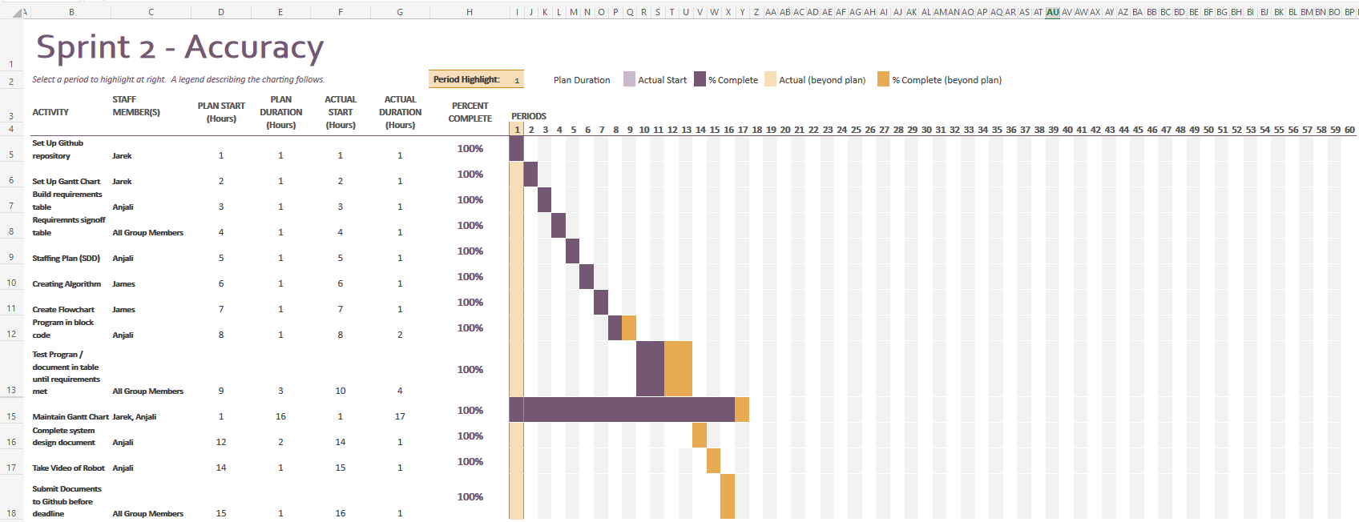

Link to excel: <https://onedrive.live.com/view.aspx?resid=7636E85E21987517!1518&ithint=file%2cxlsx&authkey=!AmpIkItjnG4q_1s>

## Staffing Plan

| Name | Role | Responsibility | Reports To |
| --- | --- | --- | --- |
| Anjali | Lead Programmer | Block code, robot testing, robot video, system design document (SDD) | Jarek for GitHub |
| James | Planning | Algorithm, flowchart, help with robot testing | Anjali for SDD  Jarek for GitHub |
| Jarek | Manager | Maintain GitHub, maintain Gantt chart, help with robot testing | Anjali for SDD |